Applying For Grant
To apply for a SEAI Home Energy Grant you will need the following:
- A valid email address
- Your Meter Point Reference Number (MPRN), This can be found at the top of your Electricity Bill and is 11 digits long
- Details of Dwelling (must be built before 2011)
- Our Contractor Details:
Note: If you search for our Contractor ID only – 17794, we will show up on the system

Contractor Name | Instant Eco Homes
Contractor ID | 17794
Contractor Location | Clare
Area Serviced | Munster or Connacht

Online Application Process
- Log onto https://hes.seai.ie/GrantProcess/ApplyForGrantAfterWizard.aspx or the “Click here” link below
- Complete the application form steps to get Grant approval (Follow steps at bottom of this page if you require any guidance)
- The Grant Offer will be made online. When you click the “Accept” option on the “Confirm Offer Acceptance” screen, the Grant Offer becomes valid
- The Grant Offer, once accepted by the applicant, remains valid for 8 months from the date of issue of the Grant Offer notification

Once approved
- Once you have accepted the offer online, a letter of offer will be sent in the post to your contact address, along with the Declaration of Works forms required for claiming the Grant
- Organize for the measures for which you have received grant approval to be carried out and fully completed by us, the Contractor

Apply online for your SEAI Home Energy Grant on the below link
Click here

Click here link (Linked to https://hes.seai.ie/GrantProcess/ApplyForGrantAfterWizard.aspx

Guidance for online SEAI grant applications
Step 1 MPRN: Fill in the details required below, then proceed to next step
Tip: Cavity Wall & Attic/Roof Insulation grants apply to homes built Prior to 2011
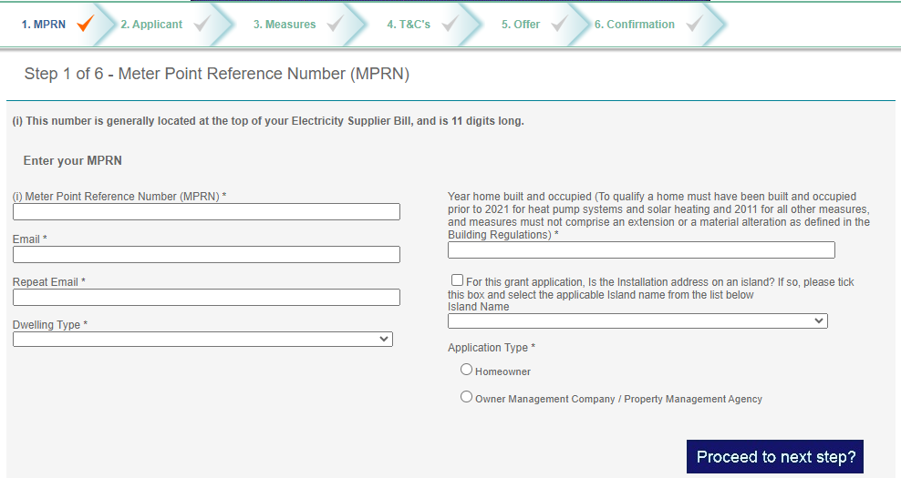

Step 2 Applicant: Fill in the details required below, then proceed to next step
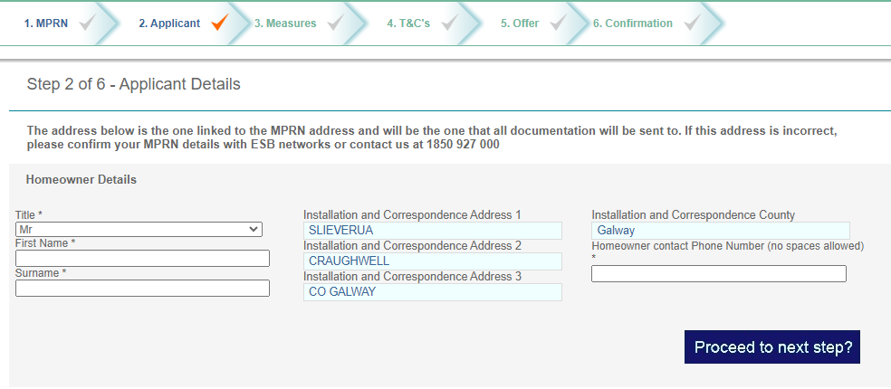

Step 3 Measures: Choose the upgrade measures you require and enter our Contractor details
Tip: Roof Insulation = Attic Insulation Upgrade
Tip: Choose CAVITY from the wall insulation drop down bar
Tip: Enter our Contractor ID - 17794 ONLY then press the SEARCH Button
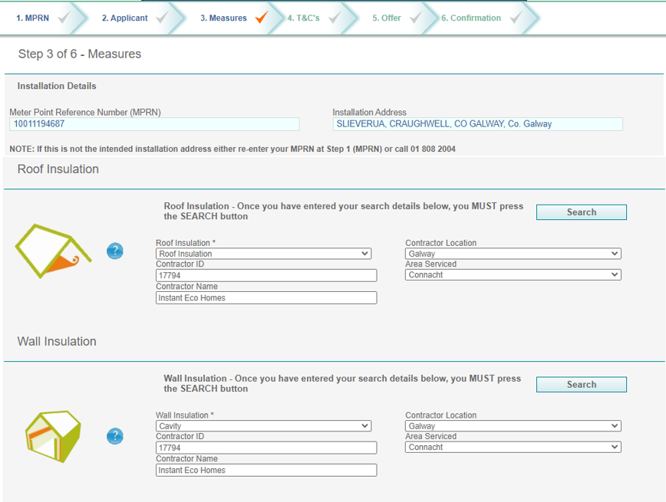

After you submit SEARCH the below page will apppear; Continue by ticking the SELECT box on the right hand side of the table for each insulation measure you choose.
Tip: A BER assessment grant of €50 will be added automatically
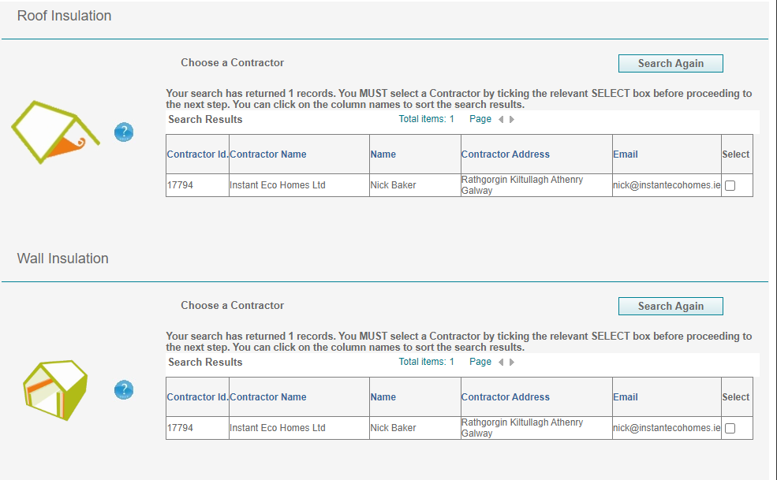

Step 4 T&C’s: Read the T&C’s and accept by ticking the box below, then proceed to next step
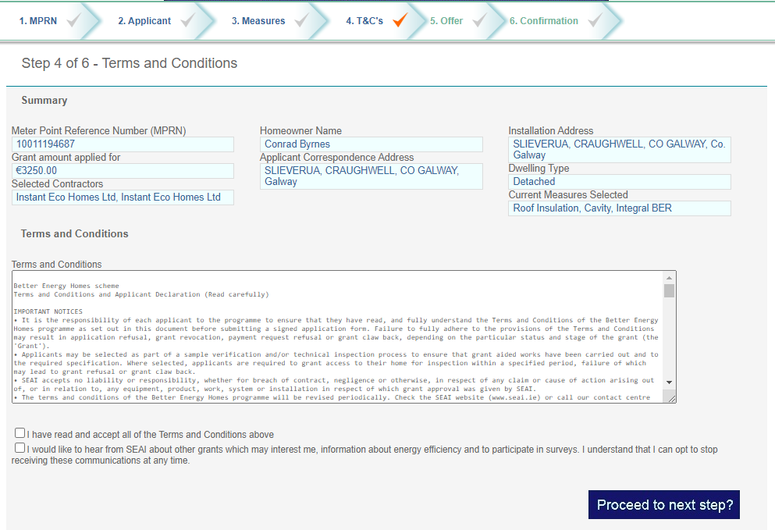
Step 5 Offer: Step 5 T&C’s: Click the ACCEPT button to make your grant application valid

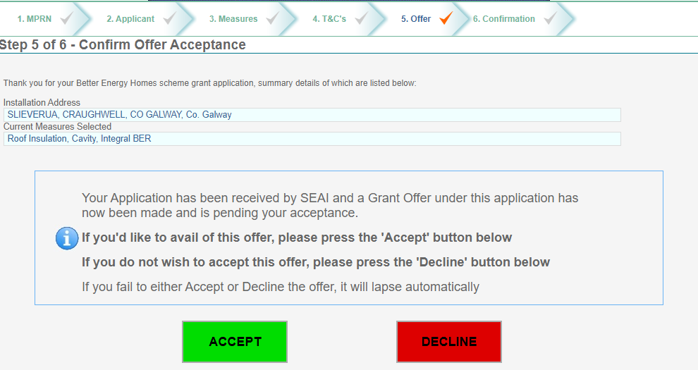

Step 6 Confirmation: Congratulations you have now activated your SEAI Grant and will receive your documenttation in the post in the coming days
